Schwebel, Adam John (from ANU website)

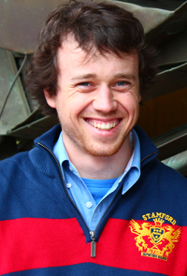

B.Sc. (Forestry) ANU 2006-2009.

Since graduating has been working in Oberon and Bathurst coordinating forest inventories as well as fire fighting for Forests NSW. Preparing for Masters in Forest Ecosystems Management in Melbourne.

